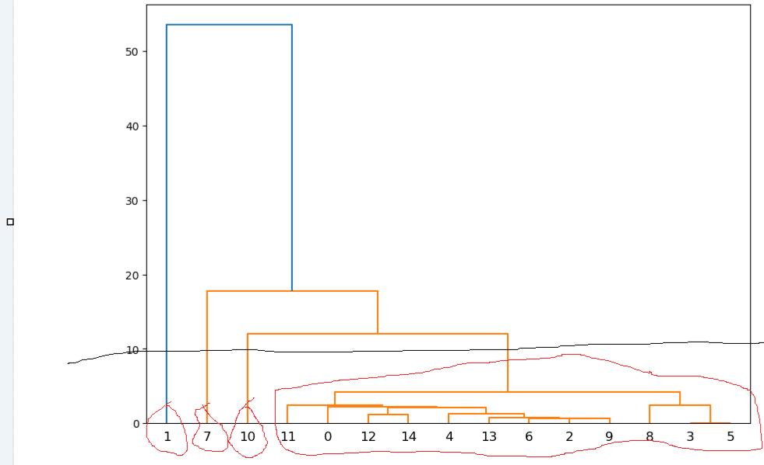

I considered 15 rows of the given dataset and as the above picture I gave the cutting line and so according to that I got 4 clusters.